**Saint Brigid Saint John the Baptist**

2nd Sunday in

Ordinary Time

January 7, 2018

**Catholic Church Catholic Church**

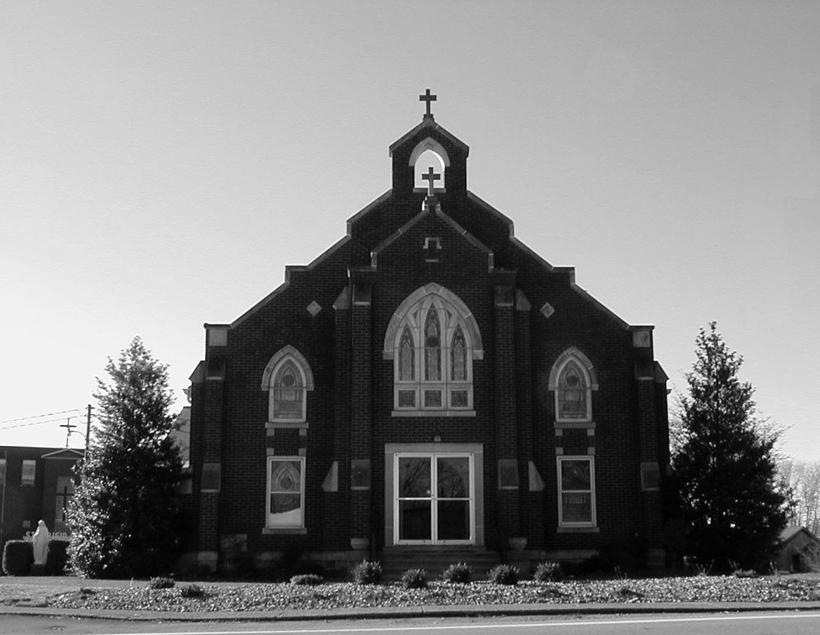

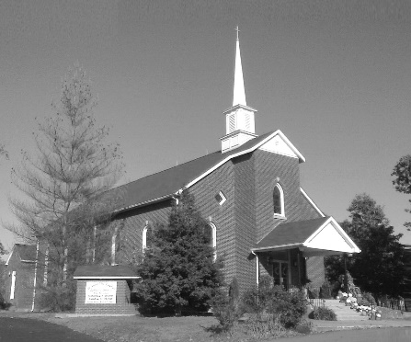

**Pastor:**

***Rev. Daniel L. Lincoln***

Rectory: (270) 877-2546

**Deacon:**

**Michael A. Ryan**

(270) 272-6789

314 E. Main St. 657 St. John Church Rd.

Vine Grove, KY 40175 Elizabethtown, KY 42701

Clustered Parish Office: Clustered Parish Office:

(270) 877-2461 (270) 877-2461

**ANNOINTING OF THE SICK:**

Notify the parish office when a family member is hospitalized.

**BAPTISM:**

Contact the parish office for information about the required preparation class.

**BULLETIN:**

Information must be submitted in writing by note or email to the parish office **no later than 12:00 noon on Wednesdays** for the following weekend. When sending an email, please put “BULLETIN,” and the name of the parish the announcement is for, in the subject line.

**MARRIAGE:**

Contact Father at least 6 months prior to the wedding date to complete required marriage preparations and to schedule the date.

**RCIA (Rite of Christian Initiation of Adults):**

Contact the Worship Chairperson for information.

**DEW MEMORIAL LIBRARY:**

(in St. Brigid Church basement):

Open: Sunday after 9:30 a.m. Mass& 45 minutes before all other Masses.

Email: [brigidvg@bbtel.com](mailto:brigidvg@bbtel.com)

Website:[www.stbrigidvg.org](http://www.stbrigidvg.org)

**Pastoral Associate & Dir. Dir. of Religious Education:**

**of Religious Education:** Lisa Thomas: (270) 735-6930

Deacon Mike Ryan (270 877-0546

**Youth Minister: Youth Ministers:**

Lori Law: (270) 723-0157 Angela Churchman:

(270) 268-9963

Ericka Finlay: (502) 612-2644

**MASS SCHEDULE:**

*Sunday:* 9:30 a.m. & 6:30 p.m.

*Monday:* 9:00 a.m.

*Thursday:* 9:00 a.m.

**RECONCILIATION:**

Sunday before Mass

5:30-6:00 p.m. or by appt.

**ROSARY:**

After weekday Masses

**PARISH COUNCIL MEMBERS:**

*President:* Sue Weisshaupt

*Vice-President:* Mike Bramlett

*Secretary:* Judy Cochran

*At-Large Members:* Blake Ryan

& Vincent Thompson

**CHAIRPERSONS:**

*Administration:* Dale Winchester

*Formation:* Tina Yates

*Parish Life:* Tom Billings

*Worship:* Keith Baughman

**MASS SCHEDULE:**

*Saturday (Vigil):*  6:30 p.m.

*Sunday:* 11:30 a.m.

*Wednesday:* 6:30 p.m.

*Friday:* 9:00 a.m.

**RECONCILIATION:**

Saturday before Mass

5:30-6:00p.m. or by appt.

**PARISH COUNCIL MEMBERS:**

*President:* Theresa Smith

*Secretary:* Karen Ray

**CHAIRPERSONS:**

*Administration:* Rick Newton

*Formation:* Ericka Newton

*Parish Life:* Bradley Wickersham

*Worship:* Nick Thomas



**Mass Schedule**

**Mass Schedule**

|  |  |  |  |  |  |
| --- | --- | --- | --- | --- | --- |
| **Saturday** | **January 13** | **6:30 p.m.** | **St. John** | **Phillip Thomas** | **Vigil: 2nd Sunday in Ordinary Time** |
| **Sunday** | **January 14** | **9:30 a.m.** | **St. Brigid** | **Harold Yates** | **2nd Sunday in Ordinary Time** |
| **“** | **“** | **11:30 a.m.** | **St. John** | **For All Parishioners** | **“** |
| **“** | **“** | **6:30 p.m.** | **St. Brigid** | **Our Parish Family**  **George Weeks** | **“** |
| **Monday** | **January 15** | **9:00 a.m.** | **St. Brigid** | **Dorothy Hulsman** | **Weekday** |
| **Wednesday** | **January 17** | **6:30 p.m.** | **St. John** | **For Special Intentions** | **St. Anthony, Abbot** |
| **Thursday** | **January 18** | **9:00 a.m.** | **St. Brigid** | **Dickie Cecil** | **Weekday** |
| **Friday** | **January 19** | **9:00 a.m.** | **St. John** | **Sid Vessels** | **Weekday** |
| **Saturday** | **January 20** | **6:30 p.m.** | **St. John** | **Bruce & Margaret Lincoln** | **Vigil: 3rd Sunday in Ordinary Time** |
| **Sunday** | **January 21** | **9:30 a.m.** | **St. Brigid** | **Harold Yates** | **3rd Sunday in Ordinary Time** |
| **“** | **“** | **11:30 a.m.** | **St. John** | **For All Parishioners** | **“** |
| **“** | **“** | **6:30 p.m.** | **St. Brigid** | **Our Parish Family** | **“** |

**INFORMATION FOR BOTH PARISHES**

**KNOW SOMEONE WHO WANTS TO BE A DEACON? DO YOU FEEL THE CALLING?** The Archdiocese of Louisville is conducting a series of *Discernment* and *Information Sessions* designed to help men who are discerning a call to become a Deacon.  Talk to Deacon Mike Ryan, or his wife Gina Ryan, if interested.  Sessions will be at St. Peter the Apostle Church, 7718 Columbine Dr., Louisville, KY 40258 - Deacon Discernment on January 18 from 7:00-9:00 p.m.; Deacon Information Session on January 21 from 2:00-4:00 p.m.

**PARISH GUIDE BOOK & DIRECTORY** – For future updates, please be sure to call the office at (270) 877-2461 if you address, phone or email changes.

**MASS INTENTIONS** – It is the beginning of a new year and Mass intentions are always needed. Plan now for your requests for the coming year and schedule early, especially if you want a specific date. Always remember, however, that dates may have to be rescheduled due to funerals, retreats, etc. Thank you for your understanding.

**CONFIDENTIAL PREGNANCY AND ADOPTION COUNSELING** – is available at Catholic Charities for women of all ages experiencing untimely pregnancies. A full range of services are provided, including adoptive placement, legal assistance and counseling for individuals, groups and families. Post-abortion counseling is also available. Services are provided regardless of income or marital status. For more information, call Catholic Charities at (502) 637-9786.

**PROJECT RACHEL** **–** Healing…Forgiveness…Hope…After the experience of an abortion. If you or someone you know is struggling with the pain from an abortion, please consider Project Rachel – a post abortion ministry. To speak to someone confidentially, call (502) 471-2155 or email [ProjectRachel@archlou.org](mailto:ProjectRachel@archlou.org).

**ROOM IN THE INN** – is a local community-based effort to help the homeless. If you are interested in this ministry, please take one of the letter/forms in the church lobby or call Betty Smith at (270) 769-3775. For more information, please contact Silvia Love at (831) 431-3293 or Silvia.h.love@gmail.com. *"Whatever you have done to one of the least of my brothers, you have done to me."* Matthew 25:40

**BLACK & WHITE KNIGHT** – Tickets for the 5th Annual Black & White Knight are now available. Tickets are $40.00 each. Dinner, Dance, Live & Silent Auction on **Saturday, February 3, at 6:00 p.m.** For tickets or more info, contact Mary Hall at (270) 268-9885.

* * * * * * * * * * * * * * * * * * * *

**St. John and St. Brigid Prayer List**

To add someone to the prayer list, please call the parish office at (270) 877-2461. **Remember to call to remove someone from the list if they are no longer sick, etc.** *Please note that the prayer list has been revised. It is primarily for parishioners and their immediate family members*.

Helen “Dinky” (Cowley) **Adams**, Sam **Adams**, April **Allen**, Dennis **Arnold**, Barbara **Ashley**, Sue **Banks**, Shannon **Barnes,** Denise **Barnett**, the **Bigler** family, Timothy **Birch**, Teresa **Laycock**, Charlie **Bowers**, Wanda **Branson**, Bill **Brown**, Ellen **Bryan**, Richard **Bryson**, Carol **Buchanan**, Jeremy & Margie **Buyer**, Ashley **Butler**, Deacon Bob **Caspar**, Sue **Caswell**, Ed **Cecil**, J. Mack **Cecil**, Harlan Ford **Clark**, John **Connor**, Betty Jo **Cooper**, Heidi **Correa**, Jeff **Craig**, Glynn **Clutches**, Roan **Dowell**, Karen **Dworshak**, Leroy **Embry**, Dwayne **Garcia**, Carrie **Gribben**, Mary **Hager**, Mrs. Charles **Hair**, Stephanie **Hall**, Donnie **Hart**, Jimmy **Harper**, Bobby **Harris**, Debbie **Hodge**, Richard **Hughes**, Betty Lou **Jones**, Andrew **Kieta**, Jenny **Leonhardt**, Jackie **Long**, Louise **Lucous**, Alma **Mahanna**, Shelly **Martin**, Shirley **Martin**, Martina **Masoni**, Don **Mattingly**, Paul Michael **Mattingly**, Mary **Medley,** Cindy **Miller**, Starla **Miller**, Doug **Osborne**, Bernard **Osborne**, Duane **Osborne**, Mickey **Padgett**, Frank **Inanely**, Annie **Pierce**, Adrianna **Porter**, Jeremy **Porter**, Allie **Ray**, Mary Agnes **Ray**, Mary Ellen **Ray**, James S. **Reed**, Tonya **Reisinger**, Joel **Rivera**, Caroline **Seabee**, Bruce **Sherrard**, Ralph **Staples**, Joan **Stith**, Keith **Tassin**, Eric **Taylor**, Anthony **Thomas**, Kenny **Thompson**, Charles **Tucker,** Raffaella **Tucker**, Debi **Turner**, Charlotte **Vowels**, Bill **Waldrop**, Lois **Weaver**, Paul A. **Whelan**, Jennifer **Williams**, Sandy **Wiseman**, Zach **Wiseman**, Gail **Wilson**, Don **Wooldridge**, Connor **Wright**, Rose Marie **Yates** and all the sick.

* * * * * * * * * * * * * * * * * * * *

**Our Military List**

To add someone to the military list, please call the parish office at (270) 877-2461. **Remember to call to remove someone from the list if they are no longer in the service**.

Lt. Matt **Bednar**, A1C Brandon **Davila**, SrA Felicia **Esquivel**, A1C Ryan **Henley**, A1C Joseph **Manco**, SPC Jacob L. **Nall**, SFC Peter **Novak**, Tony **Rickerl**, Lt. Col. Paul **Rigby**, James **Rogers**, Tony **Rogers**, Jonathon **Sifford**, Jeffrey **Slade**, Derek **Smith**, CSM Vance **Snider**, Brian **Tomassi**, A1C Daniel **Trombone**, SGT Evan **Vaughan**, Lisa **Flynn-Veri**, LT Michael **Veri**, LTC Steve **Wickersham**, SGT Clay **Wilson**, TSGT Jeremy **Yates**, Austin **Zulka** and for all who serve and have served our country.

**Rite of Christian Initiation for Adults (RCIA)**

**Date: Tuesday, January 16, 2018** **Topic:** Sacrament of Service – Holy Orders [C8]

Sacrament of Marriage [C7]

**Facilitator:** Deacon Mike Ryan

Anyone interested should contact Keith Baughman at (270) 877-5283 or the Parish Office at (270) 877-2461. Leave your name and phone number.

**ST. JOHN THE BAPTIST CATHOLIC CHURCH INFORMATION**

**Monthly Budget Amount Needed:** $ 12,500.00

**Monthly Collection for December:** $ 15,631.35

**Monthly Collection for January:** $ 4,705.51

**FR. STAN OSBORNE** – can be reached at Nazareth Home, Room 112, 2000 Newburg Rd., Louisville, KY 40205.

**WELCOME PACKETS** – If you would like to become a member, or learn more about St. John Parish, please take a *Welcome Packet* in the church lobby. You may return the census card and the stewardship form to Father Dan or place in the collection basket.

**PARISH COUNCIL** – will meet on **Monday, January 15, at 6:30 p.m.** in the Parish Hall.

**FISH FRIES** – St. John will be hosting fish fries on the following dates during Lent.

**February 23, 2018**

**March 9, 2018**

**March 23, 2018**

We will serve fresh fish, fries, hush puppies, slaw, green beans, grilled cheese and fresh homemade desserts. The proceeds will be donated to the Rineyville Community Park. Please come out for some great food, fellowship and to support a very worthy cause.

* * * * * * * * * * * * * * * * * * * *

**Religious Education**

**Classes are on Sunday from 9:45 to 11:00 a.m.**

Any questions, contact Lisa Thomas at (270) 735-6930 or glalt@comcast.net.

* * * * * * * * * * * * * * * * * * * *

**St. John Liturgical Ministers**

|  |  |
| --- | --- |
| **Vigil: 3rd Sunday in Ordinary Time, January 20, 2018, 6:30 p.m.** |  |
| Extraordinary Ministers of the Eucharist | Marcella Crewz Dennis Thomas Becky Thomas |
| Lector | Rhonda Newton |
| Servers | Katie French Volunteer |
| Greeter(s) | Joanna Sherrard |
| Gift Bearers | John & Brenda Thomas |
| Ushers | John Thomas Kenny Heibert |
| **3rd Sunday in Ordinary Time, January 21, 2018, 11:30 a.m.** |  |
| Extraordinary Ministers of the Eucharist | Lisa Parrett Doug & Shonda Leasor |
| Lector | Greg Thompson |
| Servers | Alex Powers Jordan Price |
| Greeter(s) | Lisa Parrett |
| Gift Bearers | David & Cathy Pike |
| Ushers | Trent Thomas Joe Samu |
| **Hospital Ministry – Sunday, January 28, 2018** | Marcella Brangers & Sharon Reed |

**ST. BRIGID CATHOLIC CHURCH INFORMATION**

**Monthly Budget Amount Needed:** $ 25,280.00

**Monthly Collection for December:** $ 37,419.72

**Monthly Collection for January:** $ 8,219.00

**WELCOME VISITORS** – If you are interested in joining our parish, please pick up a Welcome Packet at the church doors. Complete the registration form and either drop it in the collection basket or mail it to the office. If you just need to update your registration, there are also forms available.

**DO YOU FEEL THE CALLING TO BE A SERVER?** If you have been Baptized and received First Communion you can be an altar server. Talk to the other servers. Talk to Deacon Mike or Father Dan. Join one of the greatest ministries for people of all ages, to include adults. Call Deacon Mike at (270) 272-6789 or (270) 877-0546. Do it today!

**PARISH COUNCIL** – will meet on **Thursday, January 18, at 7:00 p.m.**

**BLOOD DRIVE** – The next drive will be held on **Friday, February 16,** from 10:00 a.m.-2:00 p.m. in the CCC building. Give the gift of life!! This is more rewarding than what else you have to do today!!

* * * * * * * * * * * * * * * * * * * *

**St. Brigid Youth Ministry**

**Wednesday, January 17** – Open gym this evening in the CCC for all youth in the 8th-12th grades. Join us from 6:30-8:30 p.m. for food, fun and fellowship.

If you have any questions, please contact Lori at (270) 723-0157 or email at [stbrigidyouth@hotmail.com](mailto:stbrigidyouth@hotmail.com).

**St. Brigid Monthly Meet and Greet**

St. Brigid Parish hosts a “Meet and Greet” downstairs the 2nd Sunday of each month immediately following the 9:30 a.m. Mass with coffee and donuts. This is a great opportunity for existing parishioners to extend a warm welcome to visitors and anyone interested in joining St. Brigid Parish. Be sure to also visit the Dew Memorial Library.

**The next Meet and Greet will be Sunday, January 14, 2018.**



**Faith Formation**

***“Soup-er Bowl”***

Come get in the game! Celebrate Souper Bowl with us at the Souper-supper!

Date: **Sunday, January 28, 2018**

Time: **4:00-6:00 p.m.**

Place: **Catholic Community Center**

Bring your favorite soup in a crockpot and we’ll keep it hot! Try a cup of one soup or ALL if you please!

**Sign-up sheets will be at the doors of the church.** Questions? Call Selina Chandler at (270) 765-3672

**St. Brigid Liturgical Ministers**

|  |  |
| --- | --- |
| **3rd Sunday in Ordinary Time, January 21, 2018, 9:30 a.m.** |  |
| Extraordinary Ministers of the Eucharist P. | Paula Greenwell Gary Morris |
| C. | Denise Hester Butch & Nan Filburn Deacon Mike Ryan |
| Lector | Rose Cooper |
| Servers | Molly Weisshaupt David Webb |
| Greeters | Charles & Pam DeRoche Volunteer |
| **3rd Sunday in Ordinary Time, January 21, 2018, 6:30 p.m.** |  |
| Extraordinary Ministers of the Eucharist P. | Ken Spangenberger |
| C. | Jim Weed Deacon Mike Ryan |
| Lector | Britany Mahanna |
| Servers | Volunteers |
| Greeters | Volunteers |
| **Hospital Ministry – Sunday, January 14, 2018** | Keith Baughman & Jim Klimesh |

*Marriage Moments –*

*“Speak, for your servant is listening.” 1 Samuel 3:18*

A common complaint among couples is, “You’re not listening to me.” When is listening hard for you? If you’re busy or tired, ask for a better time. Is there a conversation you’ve been avoiding?

* * * * * * * * * * * * * * * * * * * *

*Parenting Pointers* –

On January 15, we celebrate the contributions of Martin Luther King to racial equality and non-violence. Does your child have any friends from a different race? If not, why not? Talk, find ways to mix or read stories of a different ethnic group.

